***Antu Asif Ikbal***

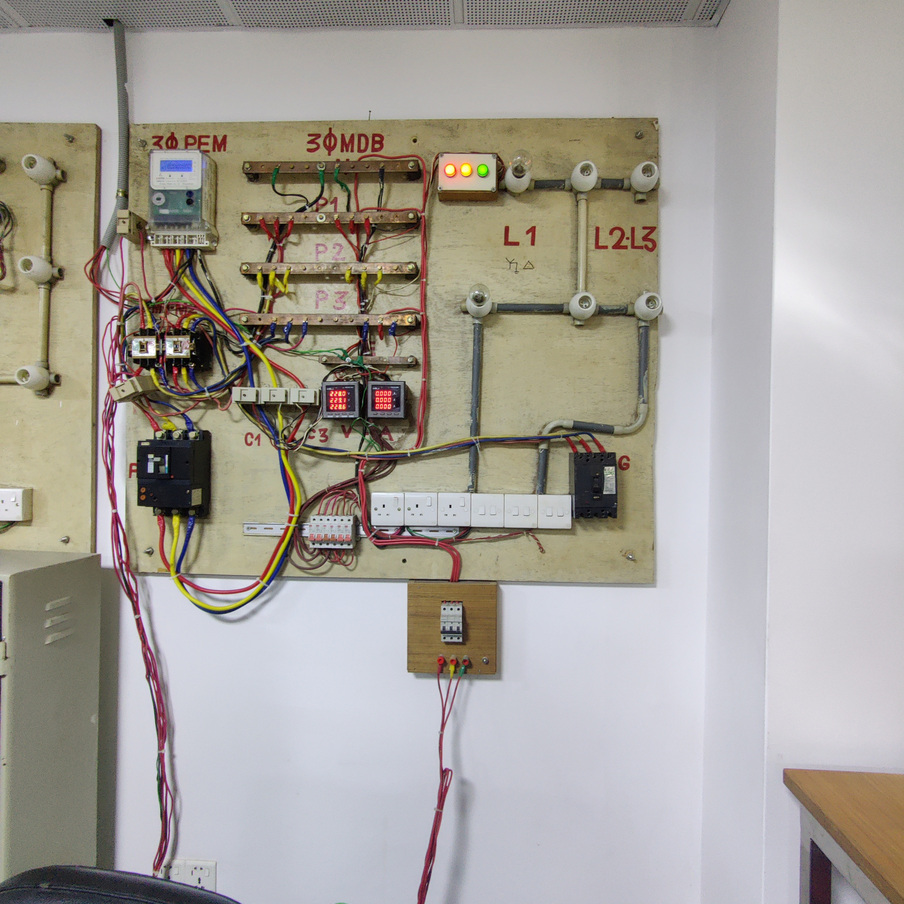

**1.Introduction**

As the market for software and online applications are growing fast,testing them is an essential part for many good reasons.Like specification review,designs ,coding etc are parts of testing software.However,we can test software in both manually and automatically.

Basically Mannual testing is to build test cases and execute them without taking any help of tools.A human sits in front a computer screen and tries different usages ,comnations of input,compares the results and checks their behavior.

And Automation testing is to use automation tools to test processes.Basic goal of automation testing is to cut down some test cases that were run manually and avoid manual testing at the same time.Couple of tools used are like jUnit,Siktest,Winrunner,Sahi,Tosca TestSuite etc…

**2.Testing Software**

In software testing , both experimental and systematical checking is important for checking correctness of a software which ensure quality to the product for its stakeholders.However,different types software requires different methods to test.Like,video game software is not operated like banking softwares.So,when a company invests in software products it also needs the assurance that it will be acceptable according to the targeted audiences and other stakeholders

**A. Different modes of testing**

**a.Manual testing :** Preparing test cases manually and executing them to identify defect in software is the main task of manual testing.Mainly it is old and most rigorous method to test a software.It is laborious activity that requires certain set of qualities like : open-minded,skillful,creative,patient,observant,speculative.When it comes to large dataset coverages for large software applications ,then repeatative manual testing can be difficult.

**Some problems with manual testing:**

**Time-**As test cases requires human to execute,it is tedious and very slow.

**Investment –**As tests are executed manually more testers are needed thus requires extra payment.

**Less reliable-**Humans cannot perform tests with precision each times because of humans errors,so it is less reliable.

**Non-programmable –**For writing sophisticated tests no programming can be done which may fetch hidden information.

Manual testing becomes boring and error prone .

**b.Automation Testing**

Automating tests involves developing test scripts that’s uses scripting languages as python,javaScript or Tool Command Language.In these way,tests can be done by computers with least human interaction.Both development and test designs can be automated by computer to reduce human effort and save the cost.

Automation softwares can enter data in the system under-test and compare actual and expected results with detailed test reports auto generated.

Most beneficial is that the test suit can be recorded and re-played as needed.Once the suite is created,human intervention is not needed any more.The tester can test relevant softwares easily.

**Benefits of automation testing are listed below:**

**Cost Effective:** less testers needed if we use automation testing.

**Repeatable:** Record and repalay can be used re-executed the whole test**.**

**Reusable:** Test suites are reused on differnet versions of softwares**.**

**Programmable:** Sophisticated tests that bring hidden information can be programmed by testers.

**Comprehensive**: Test suites can be build by testers that can cover every feature in software apps.

**More Reliable**: Precisely same operation and test can be executed each time they are run.

**Test Coverage:** Application features have wide test coverage.